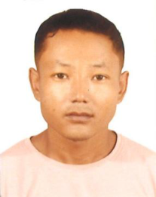

HEM SUBBA
Mob: +97433664297
Email: janam7721@gmail.com
Address: Doha - Qatar
Objective
To be integrated to an organization that will provide me career advancement and personal growth
wherein I can positively contribute more and more for the progress of the organization utilizing my
various skills and knowledge

Experience Personal Details:
Passport No. : PA3329363
• Fifteen years working experience as Driver in Qatar
QID : 28852412754
Education & certificates | Validity | : 19/09/2026

• | 10thPass | Date of Birth : 19/06/1988
Status : Married
PERSONAL ATTRIBUTES
• | Honest , trustworthy and respectful | Nationality | : Nepal

• | Quick learning and adaptability | Driving License : 28305023008
• | Flexible, optimistic and confident | Driving License : 28305023008

• | Demonstrate sound work ethics and team player | Expiry Date | : 07/10/2028

• | Maintain strict confidentiality | Languages Known

• | Creative thinking and decision-making capacity | • | English
• | Effective oral and verbal communication skills | • | English
• Arabic
• | Strong interpersonal and Organizational skill | • | Hindi
DECLARATION Skills
The information give above is true and correct to the best | • | Safe and defensive driving

of my knowledge and belief and I abide by it. | • | Route planning and
Thanking you, navigation (GPS)
• Familiarity with Qatar roads
and traffic laws
HEM SUBBA
• Time management and
punctuality
• Strong communication skills
• Clean driving record
-

