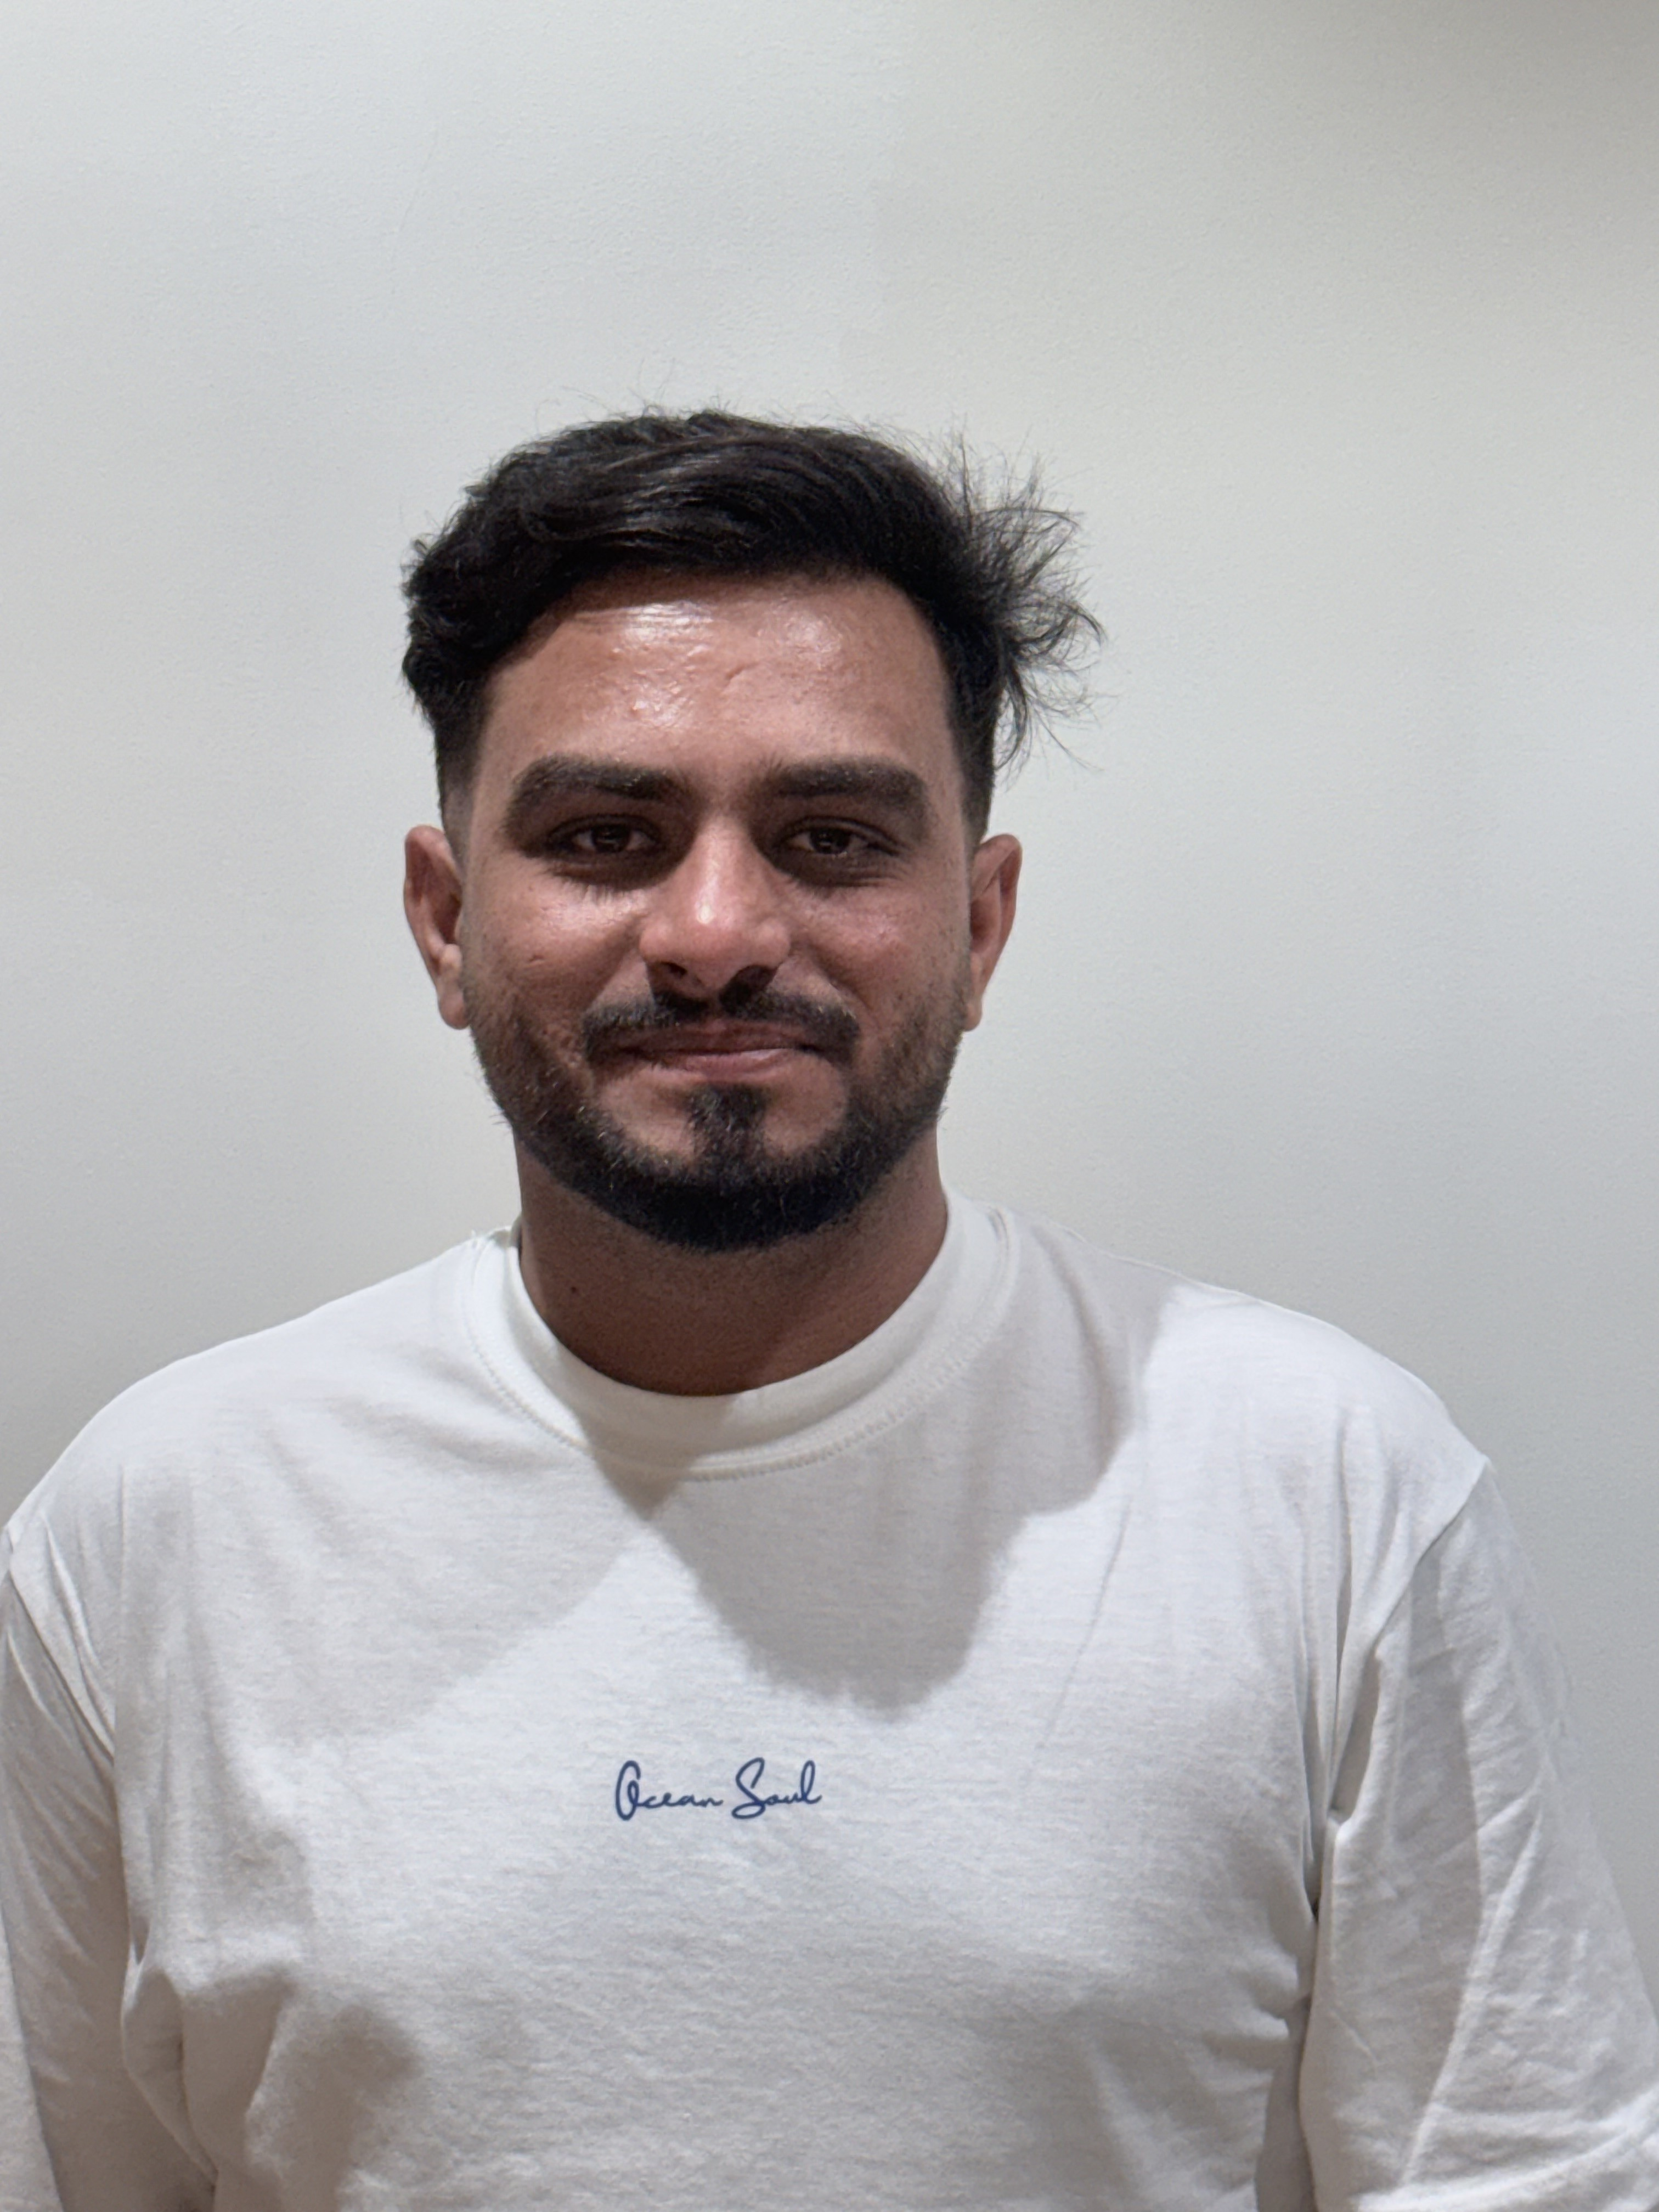  CONTACT  +974 3142 8684  abdullahzahid1267@gmail.com  Doha, Qatar  SKILLS  ◆ Driving Skills  ◆ Customer Service  ◆ Language Skills  ◆ Local Knowledge  ◆ Navigation Skills  ◆ Safety & Emergency  ◆ Communication  ◆ Time Management  LICENCES  Qatar Driving Licence  No. 30058608948  Pakistan Driving Licence  No. 3420303432951  EDUCATION  Intermediate (FSC)  FG Public College  Jhelum, Pakistan  2014 – 2015 | Muhammad Abdullah Zahid  Dynamic and experienced Tour Guide with 6+ years of experience leading immersive tours across Pakistan and Qatar. Adept at combining deep cultural knowledge, logistics management, and guest safety to create unforgettable experiences. Currently guiding tourists through Qatar's iconic landmarks with Doha Tourism.  PROFESSIONAL EXPERIENCE  Tour Guide  Doha Tourism • Mar 2024 – Present • Doha, Qatar  ▸ Guide tourists through iconic landmarks including the Museum of Islamic Art, Katara Cultural Village, and Souq Waqif.  ▸ Share engaging insights on Qatari culture, history, traditions, and modern architectural achievements.  ▸ Organise and lead desert safari experiences, ensuring safety and delivering an exciting adventure.  ▸ Educate tourists on local customs, etiquette, and dress codes for a respectful and enriching visit.  Tour Guide  Travel with Zunair • 2019 – 2022 • Pakistan  ▸ Led groups through cultural and historical destinations, providing expert commentary and storytelling.  ▸ Coordinated all logistics including transportation, accommodations, and daily activity scheduling.  ▸ Ensured the safety and well-being of all tourists throughout every tour.  ▸ Responded promptly to questions and concerns to elevate the overall guest experience.  Sales Manager  Dar Group of Companies (Korea) • 2018 – 2019 • Gujrat, Pakistan  ▸ Transported goods and products to customers, maintaining accurate delivery records.  ▸ Engaged customers to promote products and take orders, contributing to consistent sales growth.  ▸ Managed inventory levels, tracked stock, and produced regular stock reports.  ▸ Displayed and promoted merchandise at customer locations to maximise visibility.

